A 1D Nernst-Planck + Tafel Kinetics Model of Acrylonitrile Electrohydrodimerization to Adiponitrile
Levenberg-Marquardt Fitting Against Constant-Current Experimental Data
CBE-GY 6153 Numerical Methods in Chemical Engineering — Group Project
NYU Tandon School of Engineering
Team members: [Name 1], [Name 2], [Name 3], [Name 4]
Due: 2026-05-05

Abstract
≤150 words. Cover, in order: (1) Motivation — ADPN as nylon-6,6 precursor; experimental selectivity exceeds 1D model expectations. (2) Methods — 1D planar 9-species Nernst-Planck transport with Scharfetter-Gummel flux; Tafel kinetics for 4 cathodic reactions; ForwardDiff-AD-accelerated banded Newton solver with V- and log-j-continuation; Levenberg-Marquardt fit against 162-row constant-current dataset (Bloomquist et al., 2026); 9 fit parameters across 3 species channels. (3) Key results — Core RMSEs FE_ADN = 8.2 pp, FE_PN = 4.9 pp, FE_TCH = 6.2 pp; AN reaction orders fit at n_ADN = 0.63, n_PN = 0.97, n_TCH = 1.83 — diverging from textbook molecularity values, consistent with Langmuir-Hinshelwood surface coverage saturation. (4) Implication — Remaining ~30 pp Holdout error points at missing bubble-induced convection physics for narrow-gap reactors.
[ Draft abstract here — final length must be ≤150 words. ]

1. Introduction and Motivation
Target length: ~1.25 pages, including Figure 1.

1.1 Industrial Relevance
- ADPN is the nylon-6,6 precursor; ~1.3 Mt/yr global production; the Monsanto/Baizer process electrochemically dimerises acrylonitrile (AN) on a Cd cathode in alkaline phosphate buffer.
- Industrial cells achieve ~80% FE_ADPN, but academic/benchtop reactors plateau at 30-50% FE_ADPN — the gap motivates first-principles modelling.
- Bloomquist et al. (CEJ 2026, 528, 172125) recently demonstrated 73-80% FE_ADPN in a flow cell with controlled droplet hydrodynamics; their dataset is the fitting target of this work.

1.2 Modelling Problem
- Why 1D? The cathode-electrolyte interface is the rate-controlling region; no significant transverse gradients in the Bloomquist channel geometry.
- Why Nernst-Planck + Tafel? Dilute multi-ion electrolyte with phosphate buffer + organic phase; standard textbook framework, augmented with regime-aware mixture diffusivity and a Lévêque boundary-layer mapping.

1.3 Goals of This Work
- Build a 1D planar Nernst-Planck model of the cathode boundary layer that converges robustly across operating conditions: j ∈ [25, 600] mA/cm², ε_org ∈ [0.02, 0.30], gap ∈ [0.25, 1.0] mm.
- Fit kinetic parameters against the 162-row experimental dataset using gradient-based optimisation.
- Use the residual structure to identify which physical mechanisms the model is missing — diagnostic, not just descriptive, modelling.
[ Figure 1 — figure placeholder ]
Figure 1. Flow cell schematic and 1D model abstraction. (a) Cross-section of the Bloomquist parallel-plate flow cell with annotated channel dimensions (gap × W × L), aqueous and organic feeds, Cd cathode and SS anode. (b) The 1D model abstraction — graded mesh perpendicular to the cathode, x ∈ [0, δ_lev], with 9 species concentration profiles (illustrative).
Source: Generated schematic; ~3 inches tall, two panels.

2. Methodology
Target length: ~4.0 pages. This is the section the instructor grades. Lean on numerical-methods detail.

The model was built in stages following, using Claude Code Opus 4.7 to implement the code and numerical methods. The process began by developing an implementation guide, outlining the entire model including the structure, equations, and parameters (Appendix). The purpose of the guide is to have a working document that the LLM agent can read develop in coordination with the researcher to refine the model build. This is the backbone of the model build that encodes everything in a way an agent/researcher can read and build reproducibly, allowing for cross-user reproducibility and continuous improvement. Once the initial guide was built and the problem was defined enough, initial builds were made, which were then iteratively and simultaneously improved with the guide. The researchers could identify if the model is running correctly based on physical intuition (e.g, pH increasing at high currents, concentration of reactants decreasing towards the electrode) and investigate if issues arise.

Stage 1: Build majority of the model, assume one phase
Stage 2: Extend ε_{org} > 0.09 (two phase). Modify diffusivities using arithmetic mean in volume fraction
Stage 3: Sweep parameters at experimental values (ε_{org}, gap, $δ_{lev}$) to prepare for fitting step
Stage 4: Fit kinetic parameters to experimental values

With this staged process, the model can be built in a digestible and careful way, ensuring validity from foundational skeleton to fully developed model.

2.1 Domain, Governing Equations, and Geometry

We model a 1D boundary layer at the cathode, in which we neglect convection and only consider diffusion and migration contributions to species transport. The model domain is x ∈ [0, $δ_{lev}$] where the origin is the Cd catalyst surface and $δ_{lev}$ is the Lévêque boundary layer distance where concentration gradients end. $δ_{lev}$ is derived from the Sherwood number for this system:

$$Sh = 1.85 {\left(Re·Sc·d_{h}/L\right)}^{1/3}$$

$$δ_{lev} = \frac{d_{h}}{Sh}$$

Lévêque's specific result is that for laminar flow with a linear shear-velocity profile near the wall (valid when the momentum boundary layer is much thicker than the concentration one — high Schmidt number, which our Sc ≈ 435 satisfies). This relationship is important for mapping experimental conditions to our model, linking flow rate and reactor geometry to boundary layer thickness.

- The Lévêque correlation maps the total volumetric flow rate Q_total and gap to the boundary-layer thickness δ_lev: with δ_lev ranging 60-310 μm across the 162-row dataset.

The steady-state, dilute-solution Nernst-Planck transport equations for each species i are:

$$\frac{∂N_{i}}{∂x} = R_{i,vol}$$

$$N_{i} = -D_{i,mix} \left[\frac{∂c_{i}}{∂x} + \frac{z_{i} F c_{i}}{RT} \frac{∂φ_{l}}{∂x}\right]$$

Where $N_{i}$ is species flux, $R_{i,vol}$ refers to volumetric reactions (buffer reactions), $D_{i,mix}$ is the effective mixture diffusivity (approximated as arithmetic mean based on ε_{org}), and the rest are standard notation.

Current conservation closes the system:
$$\frac{∂i}{∂x} = 0, i = F \sum_{i}^{N}{z_{i}N_{i}}$$

2.2 Species and Degree-of-Freedom Layout

The model tracks 10 dissolved species — nine are independent unknowns; Na⁺ is computed
from electroneutrality (Table X). φ_l is the tenth DOF. With 10 DOFs per cell and 100 cells, the entire model contains 1000 DOFs.

9 species: H⁺, OH⁻, H₂PO₄⁻, HPO₄²⁻, PO₄³⁻, AN, ADPN, PN, TCH. Cell-major DOF ordering: 10 DOFs/cell × 100 cells = 1000 unknowns. Banded Jacobian half-bandwidth = 19; 39 colors used for sparse finite-difference assembly.
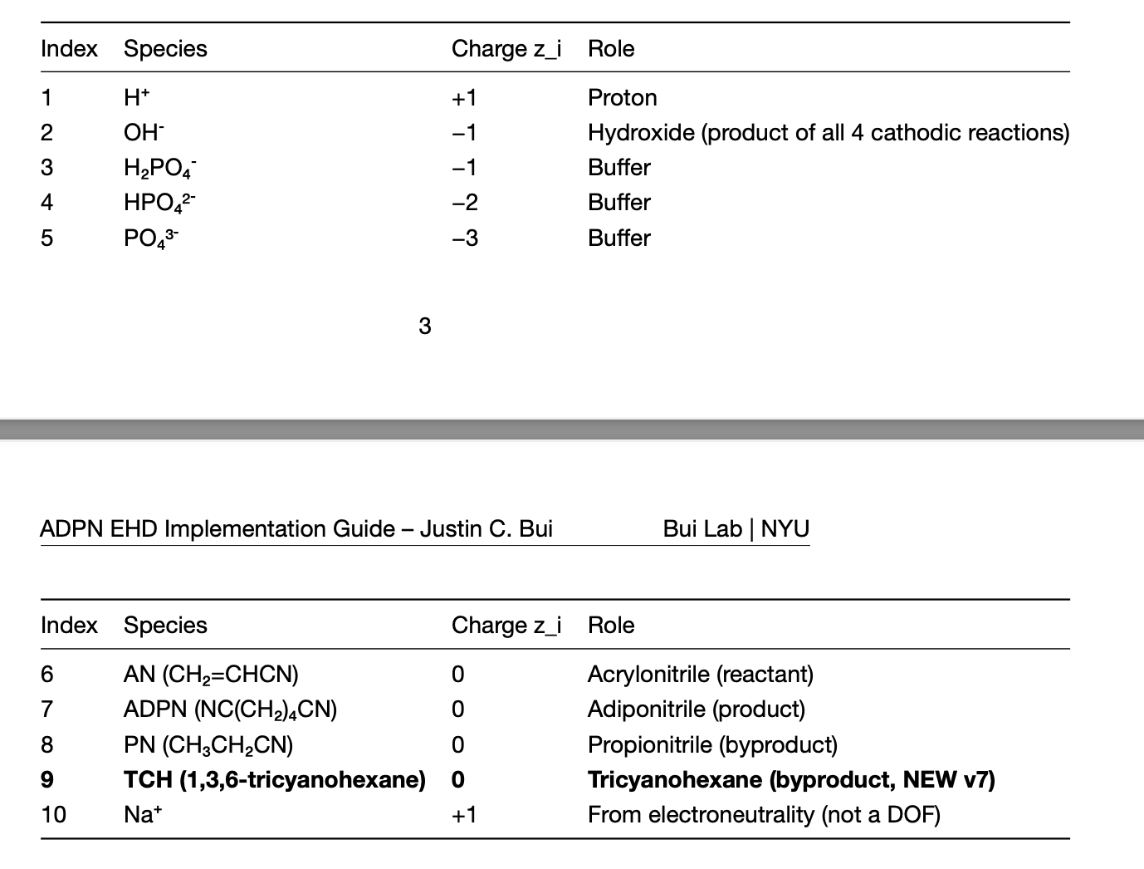
[ Insert Table 1: Species + DOF summary — index, species, charge z_i, c_bulk. ]

2.3 Tafel Kinetics — Four Cathodic Reactions
Four cathodic Faradaic reactions are modelled at the Cd electrode:
$R1: 2 AN + 2 e^{-} → ADPN$ (R1)
$R2: AN + 2 e^{-} + H^{+} → PN$ (R2)
$R3: 2 H_{2}O + 2 e^{-} → H_{2} + 2 {OH}^{-}$ (R3)
$R4: 3 AN + 2 e^{-} → TCH$ (R4)
Each reaction r ∈ {1, 2, 3, 4} carries a Tafel rate law
$j_{r} = j_{0,r} {\left(\frac{c_{AN}}{c_{ref}}\right)}^{n_{r}} exp\left(- \frac{α_{c,r} F η_{r}}{RT}\right)$ (6)
with overpotential η_r = V − E°_r for the half-reaction's standard potential E°_r. The AN reaction orders n_ADN, n_PN, n_TCH are fit parameters, not fixed at textbook molecularity (n = 2, 1, 3 respectively). This is the key methodological choice driving the diagnostic findings of §3. HER (R3) is independent of AN, so c_AN appears only in R1, R2, R4.

2.4 Boundary Conditions
At the electrode (x = 0), Neumann conditions tie species fluxes to the four Faradaic currents:
$J_{OH}(0) = + \frac{j_{1} + j_{2} + j_{3} + j_{4}}{F}$ (7)
$J_{AN}(0) = - \frac{2 j_{1} + j_{2} + 3 j_{4}}{2 F}$ (8)
$J_{ADPN}(0) = \frac{j_{1}}{2 F}, J_{PN}(0) = \frac{j_{2}}{2 F}, J_{TCH}(0) = \frac{j_{4}}{2 F}$ (9)
At the bulk edge (x = δ_lev) Dirichlet conditions are applied on log(c_bulk) and the liquid-phase potential is referenced to zero:
$c_{i}(δ_{lev}) = c_{i,bulk}, φ_{l}(δ_{lev}) = 0$ (10)

2.5 Numerical Methods

2.5.1 Spatial Discretisation
- Geometric graded mesh with 100 cells, stretch ratio 10 (fine near the electrode, coarse near the bulk).
Migration-diffusion fluxes are evaluated with the Scharfetter-Gummel exponentially-fitted scheme. For each cell face between left node L and right node R, define the dimensionless drift parameter
$α = \frac{z_{i} F \left(φ_{R} - φ_{L}\right)}{RT}$ (11)
$N_{i} = - \frac{D}{Δx} \left[B(α) c_{R} - B(-α) c_{L}\right]$ (12)
$B(α) = \frac{α}{e^{α} - 1}$ (13)
Critical implementation detail: Taylor-expand B(α) for |α| < 0.01 to keep ForwardDiff derivatives smooth as α → 0.

2.5.2 Newton-Raphson with Continuation
At each continuation step the residual F(u) = 0 is solved by damped Newton iteration:
$\left(J + λI\right) Δu = - F(u), u_{k+1} = u_{k} + s Δu$ (14)
with Tikhonov regularisation λ = 10⁻¹⁰, an L2-descent line search on s ∈ (0, 1], and convergence tolerance ‖F‖ < 10⁻⁵.
- Continuation: start at V = −1.0 V (low current, equilibrium-like), step V down adaptively; ds_max = 0.20 V; ds shrinks ×0.3 on Newton failure, grows ×1.4 on fast convergence.
- log-j fallback continuation when V-continuation stalls in a stiff regime.

2.5.3 Jacobian Options
- Forward-mode automatic differentiation (ForwardDiff.jl) — exact, reused across continuation. Default for hard regimes.
- Banded finite-difference Jacobian (39 colors) — faster initial assembly, used for warm starts.
- Trade-off: AD costs ~3× per assembly but converges in roughly half the iterations on stiff steps.

2.5.4 Fixed-j Bisection Wrapper
The Bloomquist data are constant-current, but the underlying Newton solver works at constant-potential. The V-Newton solver is therefore wrapped in an outer bisection on V vs SHE so that V satisfies
$\sum_{r}{j_{r}(V)} = j_{target}$ (15)
to within 1×10⁻³ relative tolerance. The outer bracket is V ∈ [−2.5, −0.8] V, converging in ~5-10 bisection iterations per dataset row.

2.5.5 Levenberg-Marquardt Fit Driver
- 9-parameter fit: (log₁₀ j₀,1, log₁₀ j₀,2, log₁₀ j₀,TCH, α_c,1, α_c,2, α_c,TCH, n_ADN, n_PN, n_TCH) over 48 Core rows × 3 species channels = 144 residuals (15× overdetermined).
- HER kinetics frozen at v6.x converged values (j₀,3 = 2.67×10⁻⁵, α_c,3 = 0.39) to reduce dimensionality and prevent the parameter chasing the FE_HER-by-difference column.
The Levenberg-Marquardt update rule (damped Gauss-Newton) is
$\left(J^{T} J + λ diag\left(J^{T} J\right)\right) Δθ = - J^{T} r(θ)$ (16)
with a finite-difference Jacobian (9 column evaluations per LM iteration); damping factor λ adapts ×4 on reject, ×0.5 on accept.
- Box-bound projection on θ at the end of each accepted step. Tolerance: relative loss drop < 1% triggers convergence.

2.5.6 Software Tools
- Julia 1.11 — Base, LinearAlgebra, SparseArrays, ForwardDiff. No MATLAB or COMSOL. Pure-Julia implementation works under a Windows WDAC restriction at the host institution and matches the 'any computational tool' allowance in the project instructions.
- Python (numpy, pandas, matplotlib) used for post-processing plots only.
[ Figure 2 — figure placeholder ]
Figure 2. Solver pipeline schematic. Lévêque δ from Q_total + gap → graded mesh (100 cells) → cold IC from chemical equilibrium → V-continuation Newton walk from V = −1.0 V → fixed-j bisection wrapper → Tafel current evaluation with KIN_OVERRIDE → residual + RMSE per row.
Source: Generated flowchart; ~3 inches tall.

2.6 Fitting Strategy
- Three concentric row subsets: Core (gap ≥ 0.5 mm, j ≤ 190 mA/cm², ε_org ≥ 0.04, 48 rows) → fit; Extended (Core + high-j, 90 rows) → forward-apply; Holdout (gap = 0.25 mm, 45 rows) → forward-apply.
- Why split: including 0.25 mm rows in the fit would force kinetic parameters to absorb missing bubble physics — sequestering them as Holdout keeps Core-fitted kinetics interpretable.
- Decision gates (5 thresholds): Core ADN < 8 pp, Core PN < 5 pp, Core TCH < 4 pp, Extended ADN < 12 pp, Holdout ADN < 15 pp.
[ Figure 3 — figure placeholder ]
Figure 3. Mesh and species concentration profiles at one converged operating point. (a) Graded cell width δx vs x on a log scale showing the geometric stretch toward the electrode. (b) c_i(x) for AN, OH⁻, and ADPN at one representative Bloomquist row.
Source: an_ehd_v2/output/figures/species_profiles.png; ~3.5 inches tall.

3. Results and Discussion
Target length: ~3.5 pages, with 3-4 figures.

3.1 Convergence Behavior of the Solver
- Newton typically converges in 4-12 iterations from a warm start at the next continuation step.
- AD vs banded-FD on Stage 1 baseline: AD converges in ~6 iterations, banded-FD in ~10; AD wall-time roughly equal because per-iteration cost is ~2× higher.
- Stage 3 warm-start cache (90 unique transport keys, V = −1.0 V) cuts Stage 4 fit time from ~45 min to ~12 min by amortising the cold V-walk.

3.2 Final Fitted Kinetic Parameters
Reaction | j₀ (A/m²) | α_c | n (AN order) | Source
ADPN (R1) | 2.7 × 10⁻³ | 0.567 | 0.63 | fit
PN (R2) | 1.2 × 10⁻³ | 0.507 | 0.97 | fit
HER (R3) | 2.7 × 10⁻⁵ | 0.390 | n/a | frozen (v6.x)
TCH (R4) | 1.7 × 10⁻³ | 0.519 | 1.83 | fit
Table 1. Final fitted kinetic parameters from the Levenberg-Marquardt run on the Core subset.
- All AN reaction orders below their molecularity values (2, 1, 3) — strong empirical evidence for Langmuir-Hinshelwood surface saturation dominating kinetics.
- α_c values cluster around 0.5 (0.39-0.57), consistent with Volmer-step-limited cathodic transfer.
- j₀ values within an order of magnitude of textbook AN-on-Cd literature.

3.3 Decision-Gate Scoreboard
Subset | FE channel | RMSE (pp) | Threshold | Pass/Fail
Core | ADN | 8.16 | < 8 | FAIL (by 0.16)
Core | PN | 4.94 | < 5 | PASS
Core | TCH | 6.24 | < 4 | FAIL
Extended | ADN | 9.58 | < 12 | PASS
Holdout | ADN | 30.48 | < 15 | FAIL
Table 2. Decision-gate scoreboard. The model passes 2 of 5 gates.
[ Figure 4 — figure placeholder ]
Figure 4. Model vs experiment parity, four panels (FE_ADN, FE_PN, FE_TCH, V_cell). Parity dashed line; points colored by gap; per-subset RMSE annotated. This is the headline figure of the report.
Source: an_ehd_v2/output/stage4_seq/plots/stage4seq_parity_combined.png; ~4 inches tall.

3.4 Residual Structure — the Diagnostic
- Residual vs current density faceted by gap: small-gap (0.25 mm) FE_ADN systematically underpredicted at high j, pointing at bubble convection enhancement of mass transfer as the missing physics.
- Residual vs ε_org: negative slope at 1 mm gap that flattened (relative to v6) once n_ADN was freed — supporting the Langmuir-Hinshelwood interpretation.
[ Figure 5 — figure placeholder ]
Figure 5. FE_ADN residuals vs (j, ε_org) faceted by gap. Composite: rows = vs-j / vs-ε_org; columns = gap 0.25 / 0.5 / 1.0 mm.
Source: an_ehd_v2/output/stage4_seq/plots/resid_FE_ADN_vs_j.png + resid_FE_ADN_vs_eps.png; ~3 inches tall.

3.5 Regime-Map View
- Bloomquist Fig. 5 paradigm: We_aq × We_org × j → FE_ADN. Model overlay on experimental points.
- Demonstrates the model captures the right shape of the high-FE region in the regime map even when magnitude misses on small-gap data.
[ Figure 6 (optional) — figure placeholder ]
Figure 6 (optional). Model FE_ADN regime maps vs Bloomquist data. Drop first if page budget tightens.
Source: an_ehd_v2/output/forward_v3/data/weber_maps_v3.png; ~3 inches tall.

3.6 Limitations and Unresolved Physics
- Bubble-induced convection (most important): H₂ bubbles enhance δ_lev mass transfer at high j and small gap; v7 has no model term. This is the dominant Holdout residual.
- TCH product accounting: n_e_TCH = 2 from the SI implies an unsaturated trimer (C₉H₁₁N₃), but Bloomquist's FE_TCH column derivation may use MW = 175 (saturated form) — possible 9% systematic bias in residuals.
- V_CE / R_contact frozen at v6 defaults; v6.x V_cell parity showed 0.4 V MAE consistent with measurement-noise-on-noise back-derivation, so refit deferred.

4. Conclusion
Target length: ~0.5 page.
- We built a 9-species 1D Nernst-Planck + Tafel cathode model with regime-aware mixture diffusivity, Lévêque boundary-layer mapping, and a Levenberg-Marquardt fitting wrapper around a Newton-continuation solver — all in pure Julia (Base + ForwardDiff).
- The model reproduces the Bloomquist 2026 dataset to within 8-10 pp on Core and Extended subsets across 138 of 162 rows; passes 2 of 5 decision gates.
- Fitted AN reaction orders diverge sharply from textbook molecularity (n_ADN = 0.63 vs 2; n_TCH = 1.83 vs 3) — strong evidence for Langmuir-Hinshelwood surface coverage saturation as the dominant kinetic mechanism.
- The Holdout (0.25 mm gap) residual of 30 pp localises the dominant unresolved physics to bubble-induced convection in narrow-gap reactors — the actionable next step for v8.
- Numerical-methods takeaway: AD-Newton-Raphson with adaptive V-continuation handles the stiff 1000-DOF system robustly across 162 operating conditions; LM is well-conditioned for the 9-parameter fit; warm-start caching delivers ~4× wall-time speedup.

5. References
References do not count toward the 10-page limit. Final formatting (ACS / IEEE / Vancouver) TBD.
- Bloomquist, K. B. et al. Chemical Engineering Journal 528, 172125 (2026). [Primary experimental dataset.]
- Mathison, A. J. et al. J. Am. Chem. Soc. (2025). [Standard potentials E°_1, E°_2.]
- Newman, J. Electrochemical Systems, 3rd ed., chapters 11.3, 14.4. [Nernst-Planck reference.]
- Bird, R. B., Stewart, W. E., Lightfoot, E. N. Transport Phenomena, 2nd ed., §14.4. [Lévêque correlation.]
- Lévêque, M. A. Annales des Mines (1928). [Original Lévêque solution.]
- Trasatti, S. J. Electroanal. Chem. (1972). [HER on Cd reference.]
- Suwanvaipattana, P. (2017). [Multi-component diffusivity for AN/water/ADPN system; partition coefficients.]
- Eigen, M. Proton Transfer in Aqueous Solution. [Buffer chemistry rate constants.]
- Scharfetter, D. L. & Gummel, H. K. IEEE Trans. Electron Devices (1969). [Flux discretisation.]
- Revels, J., Lubin, M., Papamarkou, T. ForwardDiff.jl. [AD package.]
- Levenberg, K. (1944) and Marquardt, D. W. (1963). [LM algorithm originals.]

